PennAccess: Walnut Street, 3401

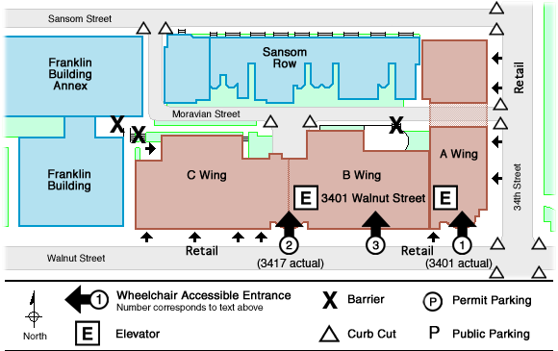

Entrance Information:
3401 Walnut Street . Philadelphia . PA . 19104

1. The A Wing entrance on the corner of 34th and Walnut Sts. is level with the sidewalk. The elevator is directly inside a pair of manual doors.
2. The entrance to B & C Wings is located further west on Walnut St. towards 36th St (3417 Walnut). The entrance is level with the elevator located directly inside a pair of manual doors.
3. The south entrance to the food court from Walnut St. is level with the sidewalk, with manual inside doors.

Note: The building is divided into three Wings. There is no interior, public connection between A Wing and the B & C Wings.

• There are retail stores at sidewalk level along 34th Street and Walnut Street. See Building Information for accessibility.

Elevator Information:
• There is a bank of two elevators on the east side of the building in A Wing which serves A Wing only.
• There is a bank of two elevators on the west side of the building in B & C Wings which serves B & C Wings only. From the second floor there is a ramp to the C Wing second floor offices. The hallway leading to the ramp is locked, but has a phone beside it.

Accessible Restrooms:
• All restrooms are accessible.
• Food Court - women's and men's (the women's is on the west in the rear and the men's is on the east in the rear.)
• There are no public restrooms within the individual retail stores.

Building Information:
• This building is divided into three Wings, A, B and C. The entrance to A Wing provides access only to A Wing. The entrance to B & C Wings provides access only to B & C Wings.
• There are 5 shops and a Food Court along Walnut Street. All are accessible. There are 6 shops along 34th Street. All are accessible. A restaurant is located in the northwest corner of the building, off of Moravian Street. Both the inner restaurant and the outside eating area are accessible.
• For more information, call Operations Control Center, at 215.898.7208.

Hours:
• The School of Arts & Sciences has classrooms located within 3401 Walnut, which are open to the public: Monday through Friday. A Wing is open from 7:00am to 7:00pm. B & C Wings are open from 7:00am to 6:00pm.

